**Set of geometric framed art**

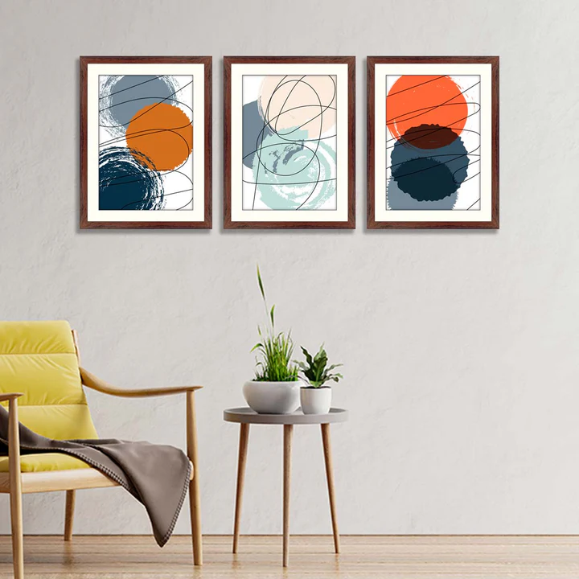A Set of Geometric Framed Art is a modern and stylish collection of artworks that incorporates bold shapes, clean lines, and intricate patterns to create visually striking pieces. Often featuring a variety of geometric designs such as triangles, circles, squares, and abstract forms, this art set adds a contemporary flair to any space. The frames, usually made from sleek materials like wood or metal, complement the artwork, allowing the geometric patterns to stand out as the focal point. Perfect for living rooms, bedrooms, or offices, this set brings a sense of balance, structure, and sophistication to your home décor. Ideal for lovers of minimalist, modern, or abstract art, it serves as a timeless addition that enhances the overall aesthetic of your space.